A Study In Scarlet - Chapter 3 知识点总结

2016-12-17 百词斩阅读

**• 12月17日知识点总结 •**

A Study In Scarlet - Chapter 3

今天这一章又是历史性的一幕，同居开始咯！

**• 讲义总结 •**

1. We met next day as he had arranged, and inspected the rooms of No. 221B, Baker Street. We were both satisfied with the rooms, and agreed to take them there and then. We gradually began to **settle down** and get used to our new surroundings.
   * 哈哈先撒花！就这样Sherlock和Dr. Watson搬进了贝克街221B，开启了他们的惊险刺激的探案生活（or甜蜜幸福的同居生活？）
   * **「settle down」**就是指搬到一个地方，安定下来生活。Adele那首经典的Someone like you一开头便是I heard that you’re settled down, that you found a girl and you’re married now.一听就是个伤心的故事。 [Someone Like You Adele - Pop Mothers https://res.wx.qq.com/mmbizwap/zh_CN/htmledition/images/icon/appmsg/qqmusic/icon_qqmusic_source263724.png](javascript:void(0);)
   * No.221B, Baker Street: 大名鼎鼎的贝克街221B号，先上图片：
   * 目前在这个地址是The Sherlock Holmes Museum，有机会去伦敦的同学一定要去感受下
   * 还有朋友细心为Sherlock家画出了户型图：

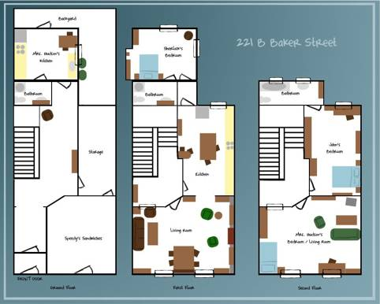

1. His appearance was such as to strike the attention of anyone who saw him.In height he was rather over six feet, and **so** excessively thin **that** he seemed to be considerably taller. His eyes were sharp and intense, and his thin nose gave his whole expression an air of alertness and decision.
   * 他的长相，仿佛就是为了吸引所有看到他的人关注（而生）。他身高差不多超过了六英尺，同时还很瘦削，这使他看起来更高了。他的眼神锐利明亮，瘦挺的鼻子让表情多了一种果断而警觉的神态。
   * **「so……that……」**这个短语有“  太……以至于……”的意思。
   * an air of alertness and decision(一种果断而警觉的神态)。 这句话给很多同学造成了困扰。首先，**「air」**有“ 神态” 的意义，这一意义不常见，注意积累哦。
   * 这里第一次详细描写到了Sherlock的外貌，大家心里面的Sherlock是什么样子的呢？书里面呢，就是这样的~
2. But now and again a reaction would take him, and for days on end he would lie upon the sofa in the sitting-room.
   * 本句可以理解为“ 但他时不时会像变了一个人似的。整天整天地躺着起居室的沙发上。**「now and again」**是“ 时不时，偶尔”。**「for days on end」**是“ 接连数日” 的意思。**「a reaction would take him」**(他像变了一个人似的)。此处reaction并不是常见的“ 反应” 意，而是“ 变化”。大家注意下积累下词组和多义词哟。
3. He was not studying medicine, nor did he appear to have followed any course of reading which might fit him for a degree in science. Yet his enthusiasm for certain studies was remarkable, and his knowledge of certain unusual subjects was so extremely full and detailed that his observations sometimes astonished me.

His ignorance was as remarkable as his knowledge. He appeared to know next to nothing of contemporary literature, philosophy and politics. Upon my quoting Thomas Carlyle, he asked the simplest questions such as who he might be and what he had done. And my surprise reached a peak when I found that he was unaware of the Copernican Theory and of the composition of the Solar System.

* + 这两段讲到Sherlock知识面的问题，他虽然不是学医的，但他对和医学相关的某些学科的研究非常厉害，他的观察能力也强到吓人。但他对于当代文学、哲学和政治的无知也是很惊人的，他甚至不知道哥白尼理论和太阳系的组成。（Sherlock认为天文学知识不重要，因此毫不关心，对此BBC改编的《神探夏洛克》第一季第三集里特意安排了一个案子，需要Sherlock用天文学知识在一幅画里找线索，也算是一种恶搞吧~）

1. There was one little pale rat-faced, dark eyed fellow who was introduced to me as **Mr. Lestrade**, and who came three or four times in a single week.
   * Mr. Lestrade第一次出场，这是伦敦警察局的一位警官，也是常年被Sherlock嘲笑的对象之一。
2. **I should like to** see him sit down in a third class carriage on the Underground, and figure out the profession of all the travelers. I would lay a thousand to one against him.
   * 本句的意思是“我倒想看他坐在地下铁路的三等车厢里，对着来往行人，指出他们一个个的职业。为这个，我赌1000块。”
   * **「I should like to」**有“ 我想要，我喜欢” 的意思。但此处联系上下文我们可以知道，华生不相信报纸上那篇文章的内容，并不觉得这篇文章的作者有多厉害。所以说这句话的时候，暗含轻蔑。因此这里I should like to理解为 “ 我倒想……” 。
   * 因为三等车厢的乘客鱼龙混杂，各行各业的都有，所以要凭借各自身上的一些特点来判断这些人的职业是很难的。然而Dr.Watson并不知道这篇文章正是Sherlock写的。

**• • • •**

第三天啦！有没有渐入佳境的感觉呢？



